Physics Lab 2

TMLTHO001 - Thomas Tumiel

# Aim

In this experiment, we aimed to manufacture a capacitor and measure its properties in different ways.

# Introduction

The capacitance of an informally constructed capacitor can be measured in different ways, each with varying degrees of uncertainty. In this lab report the measurement of such a capacitor and the different uncertainty analyses are presented.

# Method

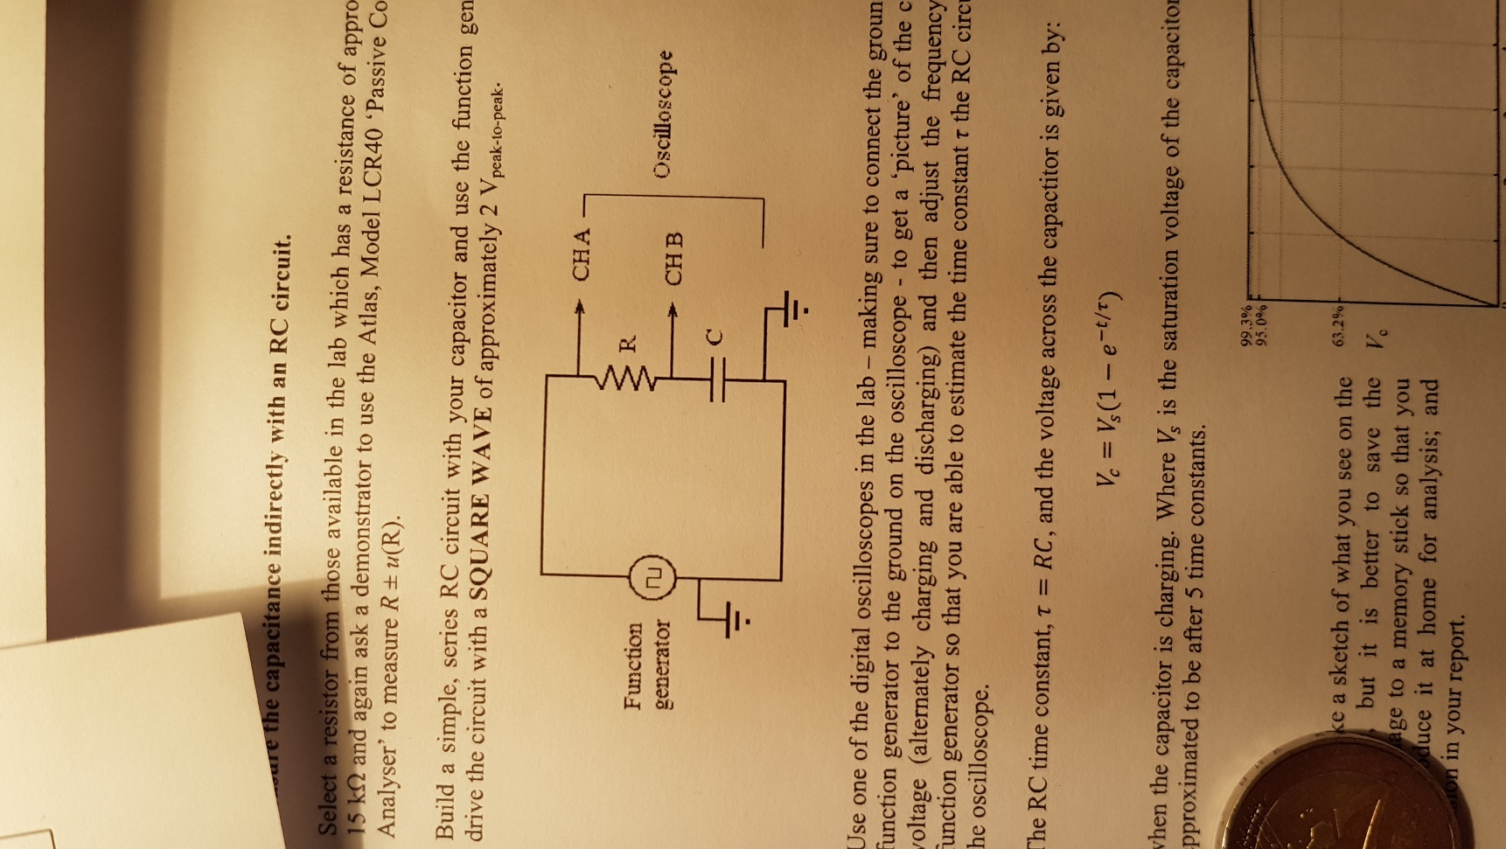The capacitor was made by rolling 2 sheets of tin foil, separated by a layer of waxpaper around a pen. The capacitance is then measured in different ways. First it is measured by calculation using the formula: where and are relative permittivity’s, A is the area of the plate and d is the distance between the plates. Next, the capacitance is measured directly using an Atlas Model LCR40 passive component analyser. And finally, the capacitance is measured indirectly through an RC circuit using the formula .

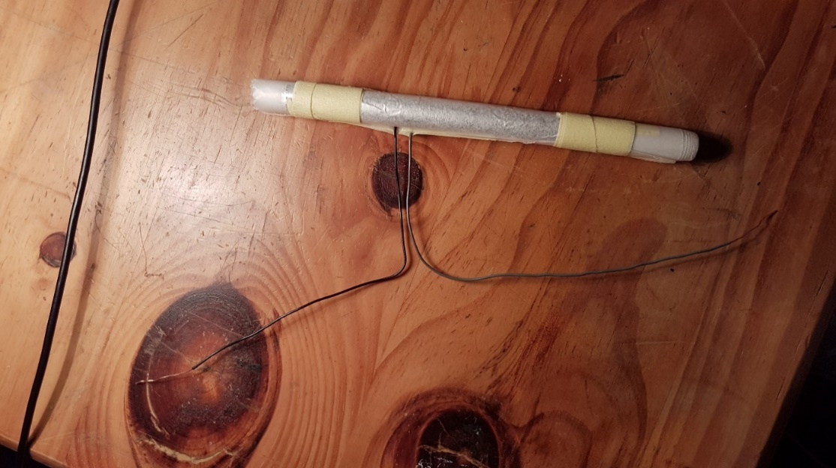

*Figure 2 – Circuit diagram of the RC response set-up*

*Figure 1 – Photo of the constructed capacitor*

# Results

**Method 1: Measurement by calculation**

This method of measurement uses the formula for calculating capacitance based on the physical attributes of the device.

where

**Method 2: Direct Measurement**

Direct measurement uses the Atlas LCR40 passive component analyser to determine the capacitance of the constructed capacitor.

**Method 3: Indirect Measurement through an RC Circuit**

After rearranging the formula: and solving for C, it can be found:

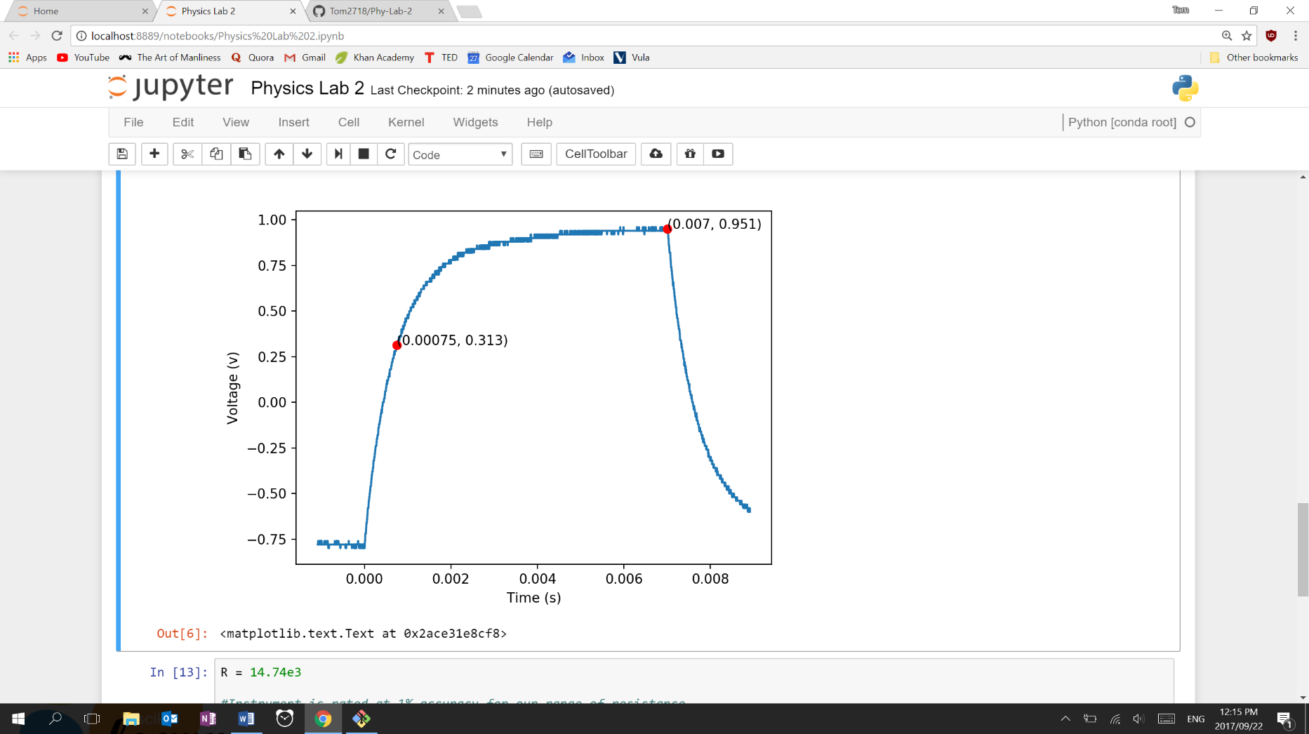

*Figure 3 – Reconstruction of signal response of RC circuit*

# Discussion

All results vary but these results are meaningless without any uncertainty values. We will begin the discussion by first looking at the uncertainty values of the results.

## Uncertainty

**Method 1: Measurement by calculation**

The measurement of the area is a composite function of the length and breadth. Each measurement has an uncertainty of 0.5mm as the measurement was done using a ruler. The analogue reading has a triangular density function and the uncertainty is calculated as follows:

The combined uncertainty of the area is then calculated as such:

The waxpaper thickness has a digital reading with a rated uncertainty of 0.01mm. Since this is a digital reading, it has a square probability density function:

The combined uncertainty for the measurement by calculation is thus:

**Method 2: Direct Measurement**

The instrument is rated at 1.5% accuracy for our range of capacitances and so the uncertainty in the direct measurement is shown:

**Method 3: Indirect Measurement through an RC Circuit**

The indirect method of measurement has uncertainties in the measurement of the resistance and the read-off value. The instrument is rated at 1% for our range of resistances. The combination of these uncertainties is presented here:

The read of values are digital and thus have a square distribution:

Thus, the uncertainty in the indirect method of measurement of capacitance is:

## Uncertainty Budget

|  |  |  |
| --- | --- | --- |
| Uncertainty Component | Standard Uncertainty | Type of Evaluation |
| Analogue area measurement uncertainty | 2.8e-4 m^2 | Type B |
| Thickness of waxpaper measurement uncertainty | 2.9 um | Type B |
|  |  |  |
| Uncertainty of capacitance measurement | 0.78 nF | Type B |
|  |  |  |
| Measurement of resistor uncertainty | 150 ohms | Type B |
| Reading of time value from graph uncertainty | 5.7 us | Type B |

# Conclusion

It can be seen that measurements of the same capacitor can vary. The results do however within agree OOOORRRR withing experimental uncertainty.

The test of the direct measurement using the LCR40 device can be considered the most accurate. It makes the fewest assumptions of the device to be measured before taking the measurements. In our other experiments, we relied on read-offs and suitable construction methods to measure the capacitor. These assumptions cannot be known and hence cannot cause bias in the LCR40’s measurement and thus it is the best measurement.

Improvements to this experiment could include rolling the capacitor tighter, taking several measurements of …..

